COS?????

UNIT NAME

This will be the cover of your portfolio…make it nicer than this! Include unit name, your name, student id…then delete this text!

STUDENT NAME

STUDENT ID

Learning Summary Report

# Self-Assessment Details

Update header with your name and ID. Then delete this box.

The following checklists provide an overview of my self-assessment for this unit.

|  |  |  |  |  |
| --- | --- | --- | --- | --- |
|  | Pass (D) | Credit (C) | Distinction (B) | High Distinction (A) |
| Self-Assessment |  |  |  |  |

Self-Assessment Statement

|  |  |
| --- | --- |
|  | Included |
| Learning Summary Report |  |
| Test is Complete in Doubtfire |  |
| C# programs that demonstrate coverage of core concepts |  |
| Explanation of OO principles  Tick (use this one! ✓) the box with the grade you are applying for. Then delete this box. |  |
| All Pass Tasks are Complete on Doubtfire |  |

Minimum Pass Checklist

Check that you have included the minimum required details. Tick these boxes (and ones for higher grades as applies). Then delete this box.

|  |  |
| --- | --- |
|  | Included |
| All Credit Tasks are Complete on Doubtfire |  |

Minimum Credit Checklist (in addition to Pass Checklist)

|  |  |
| --- | --- |
|  | Included |
| Distinction tasks (other than Custom Program) are Complete |  |
| Custom program meets Distinction criteria & Interview booked |  |
| Design report has UML diagrams and screenshots of program |  |

Minimum Distinction Checklist (in addition to Credit Checklist)

|  |  |
| --- | --- |
|  | Included |
| HD Project included |  |
| Custom project meets HD requirements |  |

Minimum High Distinction Checklist (in addition to Distinction Checklist)

# Declaration

I declare that this portfolio is my individual work. I have not copied from any other student’s work or from any other source except where due acknowledgment is made explicitly in the text, nor has any part of this submission been written for me by another person.

Replace the text here. Then delete this box.

Update footer with unit title and name. Then delete this box.

Signature: **Your Name**

# Portfolio Overview

This portfolio includes work that demonstrates that I have achieve all Unit Learning Outcomes for COS????? Unit Title to a **Pass** level.

Change the grade and unit title. Then delete this box.

[Provide a justification for why you should receive this grade… Write this for the assessment panel – tell them why you should get this grade.

For Pass: you need to indicate how you have demonstrated all Unit Learning Outcomes to a minimal level.  
For Credit: you need to indicate how you have demonstrated all Unit Learning Outcomes to a good level.  
For Distinction: you need to indicate how you have been able to apply all of the Unit Learning Outcomes in achieving the distinction tasks.  
For High Distinction: you need to indicate how you have been able to extend beyond the material presented in the unit.

In this section, refer to the tasks you have completed. These will be attached by Doubtfire after this summary. Do not try to demonstrate the outcomes here, this is just a summary.

Think of this like a cover letter to a job application – here it is a cover letter to your grade application.]

Provide justification and delete everything in [ … ]. Then delete this box.

# Reflection

## The most important things I learnt:

[ Think about topics covered, but also other general things you may have learnt. Think about what you have learnt in this subject, and reflect on what you think were key learning points, or incidents. Did you learn what you wanted/expected to learn? ]

## The things that helped me most were:

[ List and explain ]

Reflect on your learning and discuss these areas. Read the suggestions in [ ] for each question. Write your reflections then delete the text in the [ ] and delete this box.

## I found the following topics particularly challenging:

[ List and explain – if none explain why ]

## I found the following topics particularly interesting:

[ List and explain – remove if none ]

## I feel I learnt these topics, concepts, and/or tools really well:

[ List and explain – if none explain why, refer to your pieces for evidence to support your claims ]

## I still need to work on the following areas:

[ List and explain – if none explain why, refer to your pieces ]

## My progress in this unit was …:

[ Include a screenshot of your **progress graph** from **Doubtfire**, and comment on what happened from your perspective… what does the graph say about how you approached the unit? (Login to Doubtfire to get your graph <https://doubtfire.ict.swin.edu.au)>]

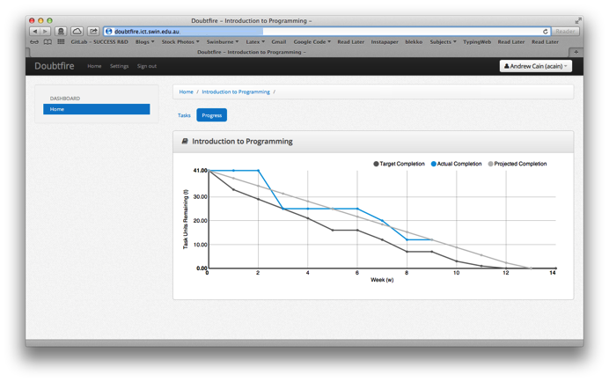

## This unit will help me in the future:

[ How will the things you learnt relate to the rest of your studies, and career. What have you learnt that will be valuable for you in the future? ]

## If I did this unit again I would do the following things differently:

[ List and explain, how will you approach learning in the future? What things worked well, but what could you change to make sure you did better next time?]

## Other…:

[ Add any other reflections you think help you demonstrate your learning ]